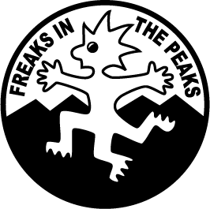
Freaks In The Peaks

CONSTITUTION
June 1996

1 NAME
The name shall be “Freaks In The Peaks”. The logo shall be as at right.

2 AIMS and OBJECTIVES
The aims shall be to perform traditional English Morris dances (from the Border tradition) to the best of our ability and for enjoyment. The club will be democratic/cooperative.
The objectives and how we achieve them:-
- public performance in and around the Peak District and further afield
- quarterly practices
- fund raising to further the aims of the group and for occasional charitable purposes
- encourage anyone who wants to learn to dance and provide workshops to improve our skill and repertoire and to interact with others
- preserve and keep alive the tradition of English Morris dancing

3 MEMBERSHIP
Shall be open to men and women over the age of 16. Juniors may attend if accompanied by an adult acting in loco parentis.
Members pay subscriptions quarterly when attending events.

4 OFFICERS
The OFFICERS shall consist of a minimum of 4 ORGANISERS whose duties shall include booking halls and pubs for quarterly events.
The officers will be elected democratically at the AGM. The officers can co-opt others as needed. Vacancies arising can be filled by the decision of the officers with a volunteer until the next AGM. Officers will present their reports at the AGM.

5 FINANCE
All monies raised shall be used to further the aims of the group. Any member with agreed expenditure made for the group will be reimbursed by the treasurer on production of receipts.

6 INSURANCE
Freaks In The Peaks shall be members of Open Morris and receive insurance under their policy.

7 EVENTS
Quarterly events shall be organised and publicised on the website for all members to attend. These shall be organised in advance and publicised at the event previous (the June event publicised at the April event, etc.)

8 TRADITIONS
The dance traditions will be from the Border tradition and composed modern dances in that style. Anyone may introduce a dance, whether traditional or composed.

9 PRACTICE/TEACHING
Will be between the hours of 10 am and 1 pm on the Saturday of each quarterly meeting. Anyone may attend this practice with the aim of learning our repertoire.

10 CONSTITUTION
Changes to the constitution can be by majority vote at the AGM.

11 DISSOLUTION
In the event of a proposed dissolution, an AGM shall be called and members will vote on the issue. Any assets remaining will be given to Open Morris or to a registered charity as decided democratically by the remaining members.

